

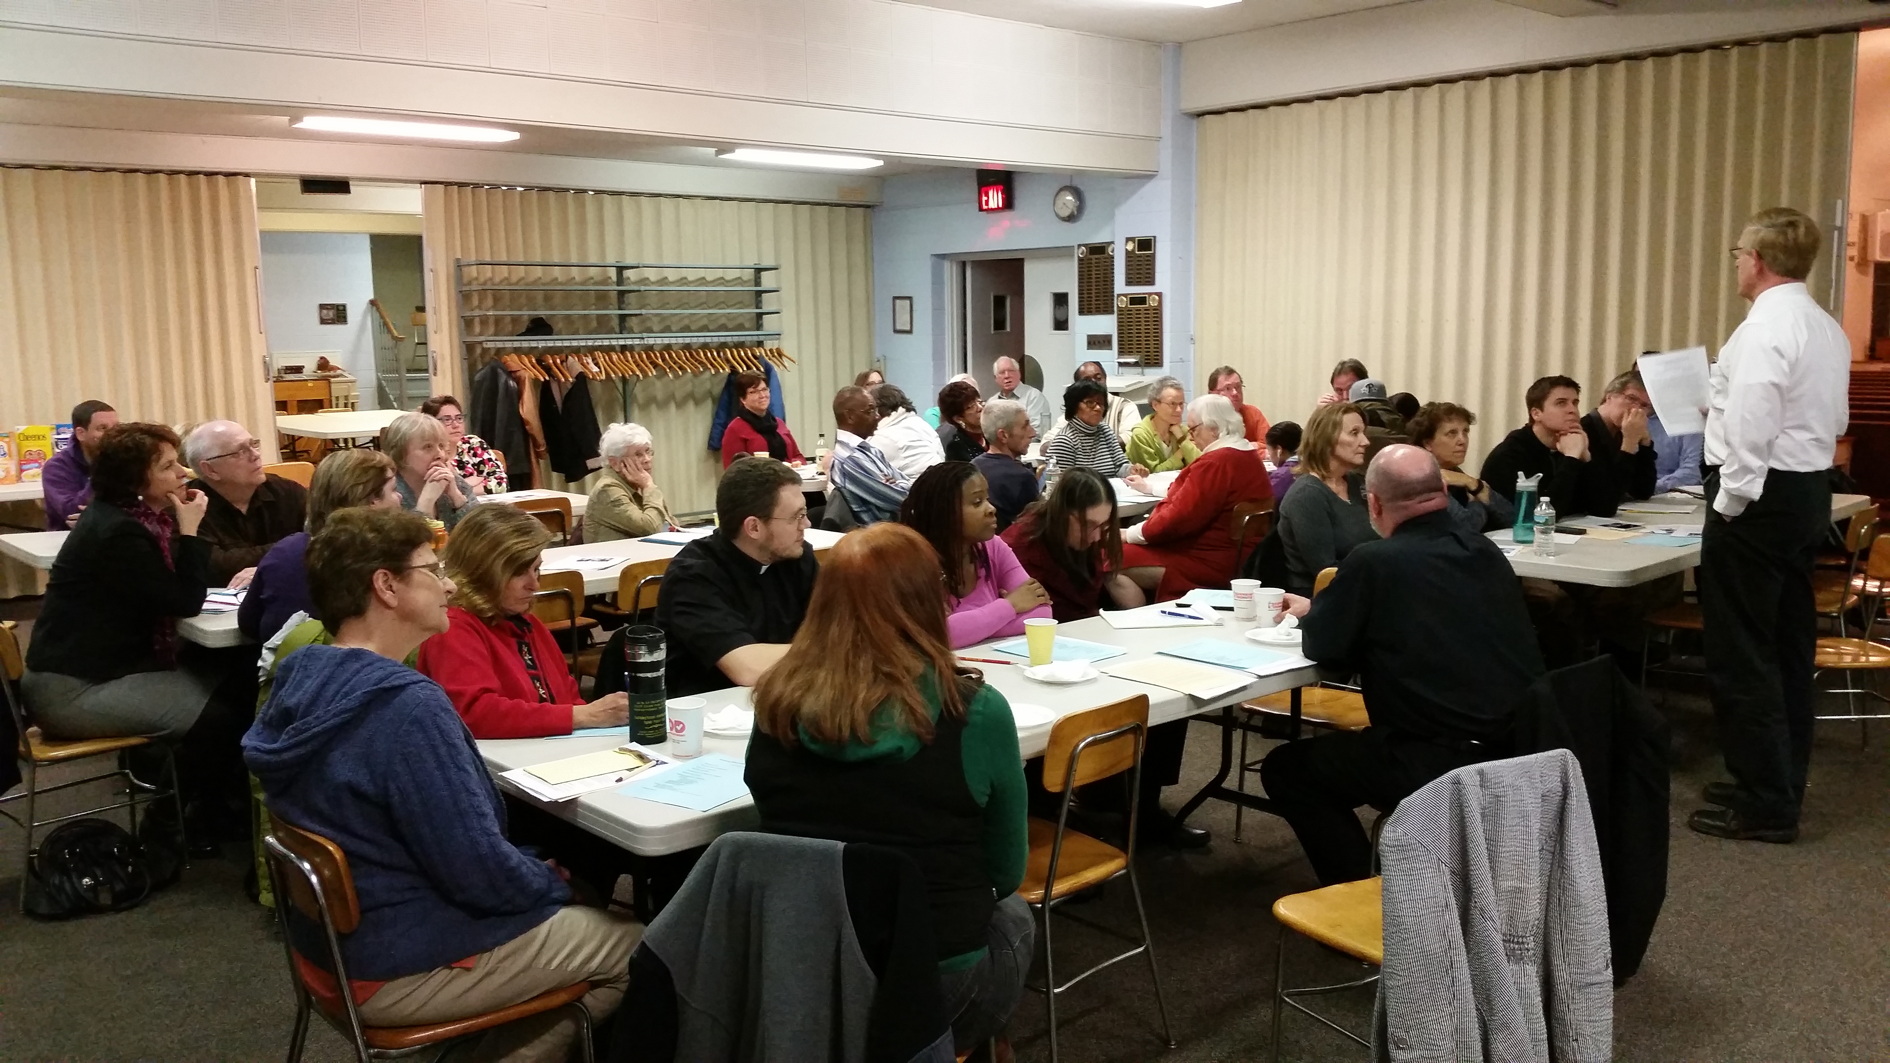

Cultivating Mission Capacity for Sustainability is a four weekend series that develops a vision and plan for growing the leadership and missional capacity of the congregation through a focus on discipleship, stewardship, community relationships and finanical development. The process is organic in that each congregation develops an approach to fit their context and culture.

With experienced facilitators/mentors equipping others through workshops and accompanying the congregational team, a cluster of 5-8 congregations journey together for up to two years. Each congregation has a team of four to six people. Several congregational disciplines are addressed through readings, educational content, learning activities and conversation. Specific outcomes are determined by the team in each congregation and have implications for engaging local neighborhoods, spiritual renewal, adaptive leadership, missional growth, regular giving, new funding sources, mission interpretation and developing a team-based approaches to ministry.

This workshop has been offered in a few synods on a pilot basis and is now being expanded. For many congregations this experience includes learning to do ministry in new ways and moving from a “paying the bills” approach to a healthier response of “living the mission”.

The basic objectives of the Building Missional Capacity for Sustainability are

Build a foundation for growing good disciples, leaders and stewards of all ages to understand a missional and sustainable approach to ministry.
Ignite personal spiritual growth while creating enthusiasm for being an evangelizing and missional congregation.
Equip congregational leaders in developing a vision and plan for living God’s call to ministry, strengthen year round ministry and nurture financial sustainability.
Accompany leaders in planning, implementing, monitoring and evaluating ministry, including an invitation for an annual financial response.
Foster stronger relationships within and among communities of faith as part of a common faith and mission.

These objectives are partially achieved through the four weekends focusing on
Weekend I 11 Hours Explore the whys of your ministry – Where are you going?
How are you growing in Christ? How are you being the
church? Understand your paradigms and the marks of being
missional
Learn about the crucial conversations necessary for
adaptive leadership to take root
How to grow disciples/stewards
Begin to develop a vision and plan
Weekend II 11 Hours Learn approaches to asset-based thinking and planning
Listening to community through one-to-ones Developing an effective year-round stewarship ministry
Discerning God’s call in your context
Weekend III 11 Hours Unpacking your community asset map
Exploring the use of non-profit vehicles
Identifying and prioritizing additional income streams
Introduction to ministry scenario analysis
Building ownership in your vision and plan
Weekend IV 11 Hours Assessing progress on the missional plan
Writing effective grant proposals
Supporting leadership, disciple and steward growth Sustaining the missional plan

As part of this weekend series, participants will receive tools to grow in their personal discipleship, leadership and stewardship while receiving resources to teach others. Each participant will receive access to assessment tools, education materials, communication elements and financial response methods. There will be regular follow-up conversations between weekends to assist congregations in moving ahead.

If you are uncertain whether your congregation is ready to particpate in this weekend series, a positive response to three or more of the questions below will provide an indication:
- Is your congregation stuck in scarcity thinking?
- Does your congregation lack a clear vision or plan?
- Do your leaders struggle to adapt to a changing environment/community?
- Has congregational giving been flat or declining?
- Is growing leaders, disciples and stewards an ongoing challenge?
- Is your congregation uncertain how to reach out to your changing neighborhood?
- Are you ready to look for additional sources of income to complement regular giving?
8. Is sustaining the momentum of ministries year round a challenge?

For additional information about Cultivating Missional Capacity for Sustainability, contact the Rev. Maristela Freiberg maristela.freiberg@elca.org, the Director for Evangelical Mission and Assistant to the Bishop of the New Jersey Synod.

