

SYNOD COUNCIL EDITION

September 2014

**New Jersey Synod**

MCj03314510000[1] MCj03314510000[1]

Renewing Hope

Strengthening Congregations,

Exploring Ministry Pathways in a Changing World

**The Fall Stewardship Cycle**

The fall stewardship conversations center on Living Generously. Pastor Scott Schantzenbach, our Synod Stewardship Specialist, will sponsor a series of Mission District based events in September and October. These conversations, Entitled, “GENEROSITY 3:16” introduce a fresh look at a familiar Bible text that will change your perspective about generosity! The format for the fall stewardship conversation will vary by mission district. Rostered leaders in the Delaware and Shore Districts will join Bishop Bartholomew for a lunch or breakfast conversation. Lay and Rostered leaders from the Northern and Gateway Districts will gather with our Stewardship Specialist, Pastor Schantzenbach, for a dessert night conversation. Congregation Councils in the Western and Middle Districts will be encouraged to use a prepared devotional guide and conversation starters at a regular meeting of the Council. All of our congregations will have access to a video venture prepared by the Resource Development Team. The specific dates and locations are:

**GENEROSITY**[](http://www.google.com/url?sa=i&rct=j&q=&esrc=s&frm=1&source=images&cd=&cad=rja&uact=8&docid=PydwcXd_IDMZGM&tbnid=Iup3EumkcWXMOM:&ved=0CAUQjRw&url=http://www.cafepress.com/%2Bchristian%2Bbumper-stickers&ei=YELiU7igCIuoyASS3IHoCw&bvm=bv.72197243,d.aWw&psig=AFQjCNGwuQfKiLU0qo4bHbxWOCi1s2ixQg&ust=1407423248917034)

September 22 Dessert Night Gateway Mission District St. Paul, Jersey City 7:00 PM

September 23 Breakfast Delaware Mission District Our Saviour, Haddonfield 9:00 AM

September 30 Dessert Night Northern Mission District Good Shepherd, Glen Rock 7:30 PM

October 13 Luncheon Shore Mission District Grace, Somers Point 12:00 PM

**THE MISSION SUPPORT TREND REPORT** is accurate through the end of August. The 2015 Mission Support goals will be distributed to our congregations as part of the fall stewardship conversations. In addition to asking for growth in mission support sharing, we are asking congregations to give consideration to adding a line to their spending plan in support of ELCA World Hunger, Malaria Campaign, Always Being Made New, Disaster.

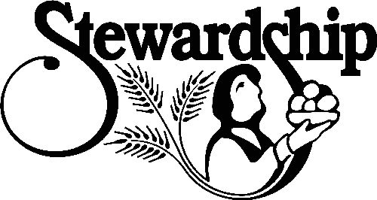We will continue to monitor Mission Support income carefully during the final quarter of this year. Our MS income is currently behind YTD 2013 levels by $26,495. Additionally, the Mission Support intents filed for 2014 do not total the amount needed to fully fund the 2014 Spending plan.

Mission Support Tracker letters were mailed last week to all of our congregations in an effort to encourage the sharing of mission support in a timely manner.

**STEWARDSHIP THEMES FOR SUPPLY PASTORS**

C:\Users\Scott\AppData\Local\Microsoft\Windows\Temporary Internet Files\Content.IE5\XDJX5016\MC900027524[1].wmfOur Stewardship Specialist, Scott Schantzenbach hosted a luncheon meeting at which he outlined stewardship themes in the fall lectionary texts. Supply pastors are frequently called upon to preach at fall stewardship programs. This preparation for supply pastors strengthens our congregation stewardship efforts during times of pastoral transition.